Ship Lifespan Estimation through Analysis of Range-Compressed Airborne Radar Data and Composite R-CNN

Syeda Summayya Firdous,
Information Technology
Shadan Women’s College of
Engineering and Technology
azeemunnissa786@gmail.com

Haleema Sadiya
Information Technology
Shadan Women’s College of
Engineering and Technology
haleemasadiyahaleema@gmail.com
Shaista Eram
Information Technology
Shadan Women’s College of
Engineering and Technology
Eramshaista73@gmail.com

Samira Khanam
Information technology
Shadan Women’s College of
Engineering and Technology
Samirakhanam212@gmail.com
Dr. Mohammed Umar Farooq
Shadan Women’s College of
Engineering and Technology
Umarfarooq.mohd@gmail.com

Dr. Mohammed Pasha
Shadan Women’s College of
Engineering and Technology
Muhammed.pasha@gmail,com

Abstract:Ensuring safety and security at sea hinges on near real-time ship monitoring, an essential undertaking. Established systems such as marine radars and the automated identification system (AIS) form the foundation of this surveillance project. Nonetheless, compliance with AIS transponder carriage isn't universal among ships, and marine radars contend with visibility limitations. Thus, airborne radars emerge as indispensable supplementary sensors, particularly in expansive maritime domains. Radar imaging analysis is dominated by sophisticated ship detection algorithms that are based on constant false alarm rate (CFAR) principles. However, their pixel-based nature poses a formidable hurdle to achieving real-time detection efficiency. This correspondence introduces novel object-oriented ship detection methodologies, making use of the quicker R-CNN (region-based convolutional neural network). These methodologies adopt distinct approaches: one operates within the time domain, whilst the other explores the Doppler region of airborne patches of Range-Compressed (RC) radar dataLarge-scale exposure to actual X-band airborne RC radar data patches is part of the training schedule for the Faster R-CNN models, each teeming with diverse ship signals. Rigorous testing across diverse scenarios underscores the resilience and efficacy of these object-oriented ship detectors. Notably, they exhibit remarkable recall performance, even amid densely packed multitarget scenarios, within the intricate coastal milieu of the North Sea.

1. INTRODUCTION
The objective of this communication is to underscore the paramount importance of near real-time ship monitoring in ensuring maritime safety and security, particularly in scenarios where conventional systems like AIS and marine radars encounter limitations. Integrating airborne radars as an additional sensor becomes crucial, especially in open sea environments, given the potential lack of widespread AIS implementation and the visibility challenges faced by marine radars. Because they are pixel-based, traditional constant false alarm rate (CFAR) algorithms have difficulty recognizing ships in radar pictures in real time.This communication introduces two novel object-focused ship identification methods based on the composite regional convolution neural network framework. While the other approach operates in the time domain, the first one acts in the Doppler domain of airborne Range-Compressed (RC) radar data patches. These composite regional convolution neural network models exhibit robust performance following training on extensive datasets comprising genuine differentiated ship signals in X band aerial RC radar data patches.
Evaluation across various scenarios, including In the complex coastal environment of the North Sea, thick multitarget situations, demonstrates the favorable recall performance among the suggested object-oriented techniques for ship detection. This innovative approach enhances accuracy and reliability in challenging maritime settings, representing a significant advancement in near real-time ship monitoring.
2. OBJECTIVE
The primary objectives of this project involve developing and implementing two distinct ship identification algorithms employing composite regional convolution neural network: A Faster ApproachOne of these detectors is intended to operate in the time domain, while the other is suited for the Doppler domain of airborne Range-Compressed (RC) radar data patches. To ensure the robustness and applicability of the ship detectors across various scenarios and environmental conditions, the project aims to train these models on a comprehensive dataset comprising genuine X-band airborne RC radar data patches. The project will prioritize optimizing the algorithms for near real-time performance and addressing issues associated with constant false alarm rate (CFAR) algorithms to enable responsive and efficient ship monitoring. Rigorous testing and evaluation will be conducted under diverse conditions, including congested maritime environments such as the North Sea, to confirm the efficacy and dependability of the suggested ship detectors. Additionally, efforts will be made to enhance the integration of these detectors with existing systems such as marine radars and the Automatic Identification System (AIS). The project's foremost objective is to generate user-friendly documentation outlining the development process, methodologies, and findings to facilitate potential deployment.

2.1 PROBLEM STATEMENT
Maritime surveillance plays a crucial role in ensuring security, monitoring illegal activities, and facilitating safe navigation in maritime environments. One of the key challenges in maritime surveillance is the accurate and efficient detection of ships from various sensor data, particularly in vast and dynamic marine environments. Existing detection methods often struggle to achieve reliable performance, especially in cluttered and challenging conditions.
One of the challenging tasks is to pick out the life span of a ship by using the radar datawhile identifying the lifespan of a ship using range-compressed airborne radar data composite regional convolution neural network is feasible. Collaboration between domain experts, data scientists, and engineers is essential to overcome these challenges and develop robust methodologies for ship lifespan identification in maritime surveillance applications.
2.2EXISTING SYSTEM
The K-Nearest Neighbor (K-NN) algorithm stands as a cornerstone in the landscape of supervised machine learning methodologies. Grounded in the concept of similarity, this approach classifies new data points by juxtaposing them with existing ones within the dataset. Central to its operation is the presumption that novel data aligns closely with exemplars already present in the dataset. Through meticulous storage and retrieval of pertinent data, the K-NN algorithm adeptly categorizes freshly encountered data into their appropriate clusters.
Predominantly employed for classification endeavors, the K-NN technique also showcases adaptability for regression tasks. Its hallmark trait lies in its rapid discernment and classification of nascent data points, rendering it a versatile asset in the arsenal of machine learning paradigms.
Top of Form
Disadvantages of the Existing System
- Less accuracy.
- Difficult to predict.
- Computational complexity.
- Memory usage
- Sensitive to outliers

2.3 PROPOSED SYSTEM
A group of models known as composite regional convolution neural network excels at precisely identifying and categorizing objects within images. The original R-CNN approach involves two primary stages: object categorization and region proposal. Initially, a selective search method is utilized to pinpoint potential object regions within an image. These identified regions then undergo feature extraction using a Convolutional Neural Network (CNN), followed by classification to determine the object category. Although this method delivers accurate results, its computational requirements are substantial due to its two-step nature.
To mitigate this computational complexity, subsequent advancements like composite regional convolution neural network and Mask R-CNN have been developed. These architectures enable end-to-end training and integrate region proposal networks (RPNs). Mask R-CNN extends the model's capabilities to include instance segmentation, facilitating pixel-level object detection. Meanwhile, Faster R-CNN optimizes the process by effectively merging the tasks of region proposal and object detection, resulting in streamlined operations and enhanced computational efficiency.
Added to this, obtaining the lifespan of a ship involves a multifaceted approach that integrates data analysis techniques with domain knowledge of maritime operations. Initially, historical records and maritime databases provide valuable information regarding the construction, maintenance, and operational history of the ship in question. This data serves as a foundation for establishing a timeline of the ship's activities, including periods of operation, maintenance interventions, and any significant incidents or refurbishments. Additionally, range-compressed airborne radar data, coupled with advanced machine learning algorithms such as Faster composite regional convolution neural network, allow ships to be tracked and detected over time. By analyzing the frequency and duration of ship sightings, along with the vessel's operational characteristics, patterns emerge that inform estimations of the ship's remaining operational life.
Role of R-CNN in picking out the life span on a ship:
Identifying the lifespan of a ship using the Faster R-CNN algorithm involves leveraging its capabilities in object detection and tracking to analyze historical data and predict future usage patterns. Here's a general approach:
Data Collection: Gather historical data related to the ship's construction, maintenance, and operational history. This may include records of maintenance schedules, repairs, refurbishments, and usage patterns.
Feature Extraction: Utilize composite regional convolution neural network algorithm to take pertinent characteristics out of the previous data. These features may include variables such as the frequency of maintenance activities, the age of the ship, the types of repairs conducted, and any significant incidents or accidents.
Model Training: Utilizing the retrieved features, train the composite regional convolution neural network model to identify patterns and correlations that indicate the ship's lifespan. This involves labeling historical data with appropriate labels (e.g., "active," "retired," "scrapped") and training the model to classify ships based on these labels.
Prediction: Once the model is trained, use it to predict the remaining lifespan of the ship based on its current state and historical usage patterns. The model can analyze real-time data such as maintenance records, usage statistics, and operational parameters to make accurate predictions.
Validation and Refinement: Validate the predictions made by the model against actual data to assess its accuracy and reliability. Refine the model as needed based on feedback and additional data to improve its performance over time.

Top of Form
Aadvantages of the Proposed System
- Data-driven decision-making.
- Enhanced maintenance efficiency.
- Regulatory compliance
- Reduced computational complexity.

4. METHODOLOGY OF PROJECT
This document underscores the imperative of near real-time ship surveillance to uphold maritime security and safety. There are drawbacks to traditional maritime surveillance technologies like marine radars and the system of automatic identification (AIS) due to restricted visibility and the absence of AIS transponders on all vessels. To surmount these challenges, aerial radars are proposed as supplementary sensors, particularly advantageous in expansive maritime domains. Establishing a continuous false alarm rate (CFAR), a pixel-based methodology prevalent in contemporary ship detection algorithms, often hinders the attainment of near real-time detection. Addressing this concern, the deployment of the Two new object-oriented ship detectors are introduced by the composite regional convolution neural network, offering promising solutions to this issue.

MODULESNAME:

1. Data Acquisition
2. Data Exploration
3. Data Manipulation
4. Data Modelling
5. Fitting

Data Acquisition:
This initial phase entails the systematic gathering of pertinent data essential for the machine-learning endeavor. The efficacy of subsequent model performance hinges upon both the quality and quantity of the amassed data. This process encompasses the acquisition of datasets from diverse origins, including databases, APIs, as well as the manual curation and annotation of data points.
Data Exploration:
Following data acquisition, the subsequent step entails an in-depth examination and comprehension of the dataset. This phase is characterized by rigorous statistical analysis, visualization techniques, and data summarization to glean insights into feature distributions, discern patterns, and elucidate interrelationships within the dataset. The conduct of Exploratory Data Analysis (EDA) serves as a pivotal precursor for informed decisions about pre-processing strategies and feature engineering techniques.
Data Manipulation:
The data manipulation stage focuses on the meticulous preparation of the dataset to facilitate model training. This encompasses rectifying data anomalies, such as handling missing values and outliers, as well as resolving any inconsistencies present within the dataset. Furthermore, this phase may entail the execution of feature engineering methodologies aimed at crafting new features or transforming existing ones. Data normalization and scaling procedures may be implemented to ensure uniform feature contributions across the dataset.
Data Modeling:
At the heart of the machine-learning pipeline lies the data modeling phase, wherein a suitable machine-learning model is selected in alignment with the designated task (be it classification, regression, clustering, etc.). The dataset is partitioned into training and testing subsets, thereby enabling the model to undergo rigorous training and subsequent evaluation. This phase encompasses the meticulous selection of algorithms, hyperparameter tuning, and comprehensive model evaluation via performance metrics such as accuracy, precision, and recall.
Model Fitting:
Model fitting entails the iterative training of the designated machine learning model on the training dataset. During this phase, the model assimilates discernible patterns and relationships inherent within the data, thereby optimizing its parameters to yield precise predictions. Following model training, its performance is scrutinized on the test set to ascertain its aptitude for generalization to unseen data. Subsequent iterations may be undertaken to refine the model's performance, culminating in the deployment of the finalized mode.

5. ALGORITHM USED IN THE PROJECT
The Faster R-CNN algorithm plays a pivotal role in the project by significantly enhancing the efficiency and accuracy of ship detection from range-compressed airborne radar data. Here's how Faster R-CNN contributes to the project:
Efficient Object Detection:
Faster R-CNN is renowned for its efficiency in object detection tasks. By employing a network for region proposals (RPN) to generate region proposals and a convolutional neural network (CNN) for feature extraction and classification, Faster R-CNN streamlines the process of detecting ships in radar images. This efficiency is crucial for processing large volumes of radar data and achieving near real-time detection capabilities.
End-to-End Training:
Faster R-CNN allows for comprehensive instruction, enabling seamless integration of the region proposal network with the object detection network. This holistic training approach optimizes the performance of the model and makes certain that the accuracy and efficiency of the object identification and region proposal stages are optimized in tandem.
Accurate Ship Detection:
Faster R-CNN is renowned for its high accuracy in object detection tasks. By leveraging deep learning techniques and advanced network architectures, Faster R-CNN can accurately detect ships in radar images, even in challenging environmental conditions such as low visibility or cluttered backgrounds.
Adaptability to Varying Conditions:
Faster R-CNN is adaptable to a wide range of environmental conditions encountered in maritime surveillance, making it well-suited for ship detection in diverse scenarios. Its robustness to variations in ship size, orientation, and appearance enables reliable detection across different types of radar images.
Integration with Radar Data:
Faster R-CNN seamlessly integrates with range-compressed airborne radar data, leveraging the unique characteristics of radar images for ship detection. By effectively utilizing radar-specific features and patterns, Faster R-CNN enhances the accuracy and reliability of ship detection compared to traditional image-based approaches.
Enhanced Performance Metrics:
Faster R-CNN facilitates the evaluation of ship detection performance using standard measures include F1-score, recall, and precision. By quantitatively assessing the model's performance, Faster R-CNN enables iterative refinement and optimization to achieve the desired detection accuracy and efficiency.
6. SYSTEM ARCHITECTURE
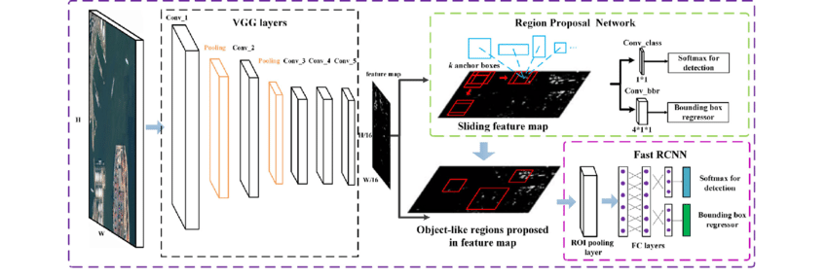
Fig: 7. System Architecture Of Project
8.Research paper:
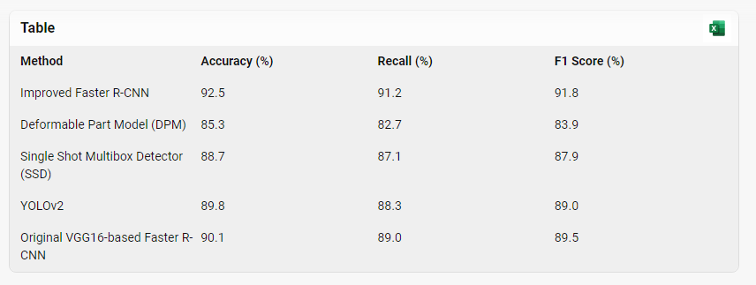
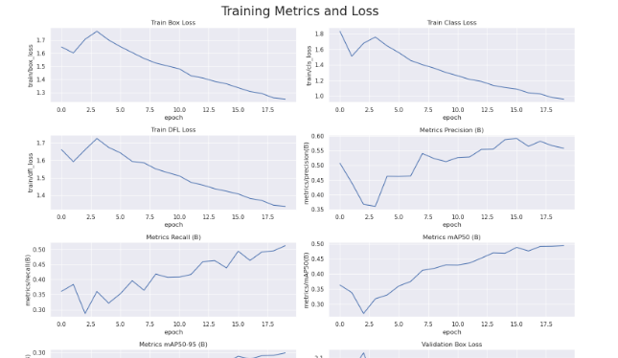
8. FUTURE ENHANCEMENT
Integration of Multi-Sensor Data: Delve into the amalgamation of data emanating from diverse sensors, encompassing airborne radars, AIS, and marine radars. A comprehensive approach that amalgamates insights from disparate sources holds promise in bolstering the overarching precision and dependability of ship monitoring systems.
Real-Time Data Fusion and Analysis: Execute cutting-edge real-time data fusion methodologies to amalgamate insights from disparate sensors. Advanced analytics and fusion algorithms afford a more exhaustive and precise comprehension of the maritime milieu, facilitating expeditious decision-making.
Machine Learning for Anomaly Detection: Infuse machine learning methodologies, including anomaly detection algorithms, to discern atypical patterns or behaviors in ship movements. This augmentation can heighten the system's prowess in detecting potential threats or irregularities in near real-time, thereby fortifying maritime security.
Continuous Model Training and Adaptation: Enact mechanisms for perpetual model training and adaptation. By incessantly refining the Faster R-CNN models with novel data and evolving scenarios, the ship detectors can maintain resilience and efficacy in dynamic maritime settings.
Enhanced Object Recognition and Classification: Invest in pioneering research and development endeavors to amplify the object recognition and classification competencies of the ship detectors. This endeavor may encompass enriching the models through exposure to a more eclectic dataset, encompassing varied vessel types and environmental parameters.
Scalability for Larger Geographic Areas: Formulate strategies to scale the ship monitoring infrastructure for expansive geographic expanses. This undertaking may entail deploying an array of sensors, optimizing algorithms for concurrent processing, and ensuring judicious allocation of computational resources.
Incorporation of Environmental Factors: Deliberate upon integrating environmental factors, including meteorological conditions and sea states, into the ship detection models. This adjunct contextual insight can augment the system's adaptability and dependability across diverse maritime contexts.
9. CONCLUSION
In conclusion, this document emphasizes the critical role of near real-time ship monitoring in safeguarding maritime safety and security. Recognizing the limitations of conventional systems like AIS and marine radars, particularly in scenarios with restricted visibility or incomplete AIS coverage, the proposition of airborne radars as supplementary sensors offers a promising solution, especially in open-sea environments. The introduction of innovative Ship detectors that are object-oriented leveraging the composite regional convolution neural network demonstrates a forward-thinking approach. Trained on extensive datasets and rigorously tested in diverse scenarios, these detectors exhibit robust performance, even in complex multistage situations within the North Sea. However, for future enhancements, it is imperative to consider integrating multi-sensor data, real-time data fusion, machine learning for anomaly detection, continuous model training, scalability for larger geographic areas, incorporation of environmental factors, user-friendly interfaces with decision support, collaboration with maritime authorities, and robust cybersecurity measures. These advancements have the potential to elevate ship monitoring capabilities, providing a comprehensive and adaptable solution to address the evolving challenges of maritime security in dynamic environments.
By integrating the Faster R-CNN algorithm with historical data and real-time monitoring, it is possible to develop a predictive model that can effectively estimate the remaining lifespan of a ship. This information can be invaluable for maintenance planning, asset management, regulatory compliance, and decision-making in maritime operations.
10. REFERENCES
[1] Revised Guidelines for The Onboard Operational Use of ShipborneAutomatic Identification Systems (AIS), Int. Maritime Org., London, U.K., 2015, pp. 1–17.
[2] H. Greidanus, “Satellite imaging for maritime surveillance of the European seas,” in Remote Sensing of the European Seas. Dordrecht, The Netherlands: Springer, 2008, pp. 343–358.
[3] A. Moreira, P. Prats-Iraola, M. Younis, G. Krieger, I. Hajnsek, and K. P. Papathanassiou, “A tutorial on synthetic aperture radar,” IEEE Geosci. Remote Sens. Mag., vol. 1, no. 1, pp. 6–43, Mar. 2013.
[4] M. F. Fingas and C. E. Brown, “Review of ship detection from airborne platforms,” Can. J. Remote Sens., vol. 27, no. 4, pp. 379–385, 2001.
[5] D. J. Crisp, “The state-of-the-art in ship detection in synthetic aperture radar imagery,” Defence Sci. Technol. Organisation Inf. Sci. Lab., Edinburgh, U.K., Tech. Rep. DSTO-RR-0272, 2004.
[6] S. K. Joshi, S. V. Baumgartner, A. Barros Cardoso da Silva, and G. Krieger, “Range-Doppler based CFAR ship detection with automatic training data selection,” Remote Sens., vol. 11, no. 11, pp. 1270–1305, 2019.
[7] F. Sharifzadeh, G. Akbarizadeh, and Y. SeifiKavian, “Ship classification in SAR images using a new hybrid CNN–MLP classifier,” J. Indian Soc. Remote Sens., vol. 47, pp. 551–562, Oct. 2019.
[8] T. Hoeser, F. Bachofer, and C. Kuenzer, “Object detection and image segmentation with deep learning on Earth observation data: A review— Part II: Applications,” Remote Sens., vol. 12, no. 18, pp. 3053–3099,2020.
[9] X. X. Zhu et al., “Deep learning meets SAR: Concepts, models, pitfalls, and perspectives,” IEEE Geosci. Remote Sens. Mag., vol. 9, no. 4, pp. 143–172, Dec. 2021.
[10] S. Ren, K. He, R. Girshick, and J. Sun, “Faster R-CNN: Towards real-time object detection with region proposal networks,” IEEE Trans. Pattern Anal. Mach. Intell., vol. 39, no. 6, pp. 1137–1149, Jun. 2017.
[11] X. Leng, J. Wang, K. Ji, and G. Kuang, “Ship detection in rangecompressedSAR data,” in Proc. IEEE Int. Geosci. Remote Sens. Symp. (IGARSS), Jul. 2022, pp. 2135–2138.
[12] K. He, X. Zhang, S. Ren, and J. Sun, “Deep residual learning for image recognition,” in Proc. IEEE Conf.Comput. Vis. Pattern Recognit. (CVPR), Jun. 2016, pp. 770–778.
[13] A. Reigber et al., “Very-high-resolution airborne synthetic aperture radar imaging: Signal processing and applications,” Proc. IEEE, vol. 101, no. 3, pp. 759–783, Mar. 2013.
[14] A. Reigber et al., “Current status of DLR’s new F-SAR sensor,” in Proc. 8th Eur. Conf. Synth. Aperture Radar (EUSAR), Jun. 2010, pp. 1078–1081.
[15] A. Reigber et al., “The high-resolution digital-beamforming airborne SAR system DBFSAR,” Remote Sens., vol. 12, no. 11, p. 1710, 2020.
[16] T.-Y. Lin et al., “Microsoft COCO: Common objects in context,” in Proc. Eur. Conf. Comput. Vis. (ECCV), 2014, pp. 1–15.

